Group BY without Aggregate

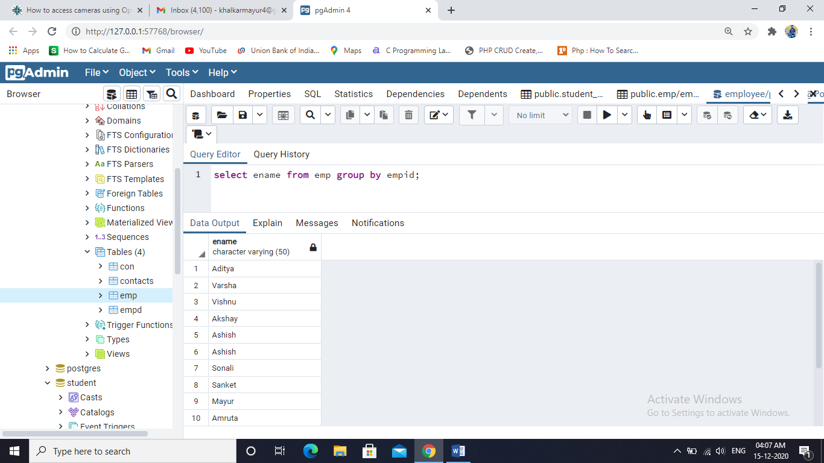

Group By with SUM

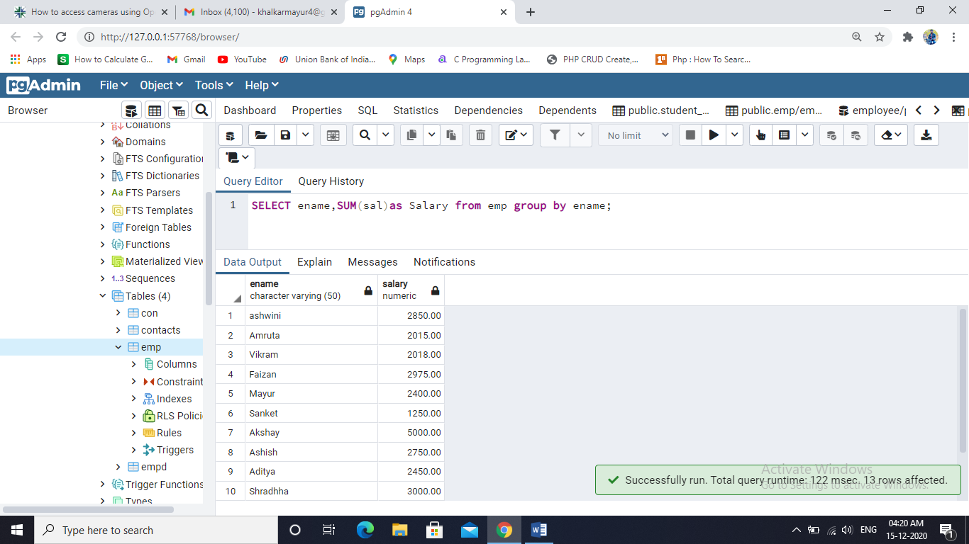

The GROUP BY clause sorts the result In Descending Order

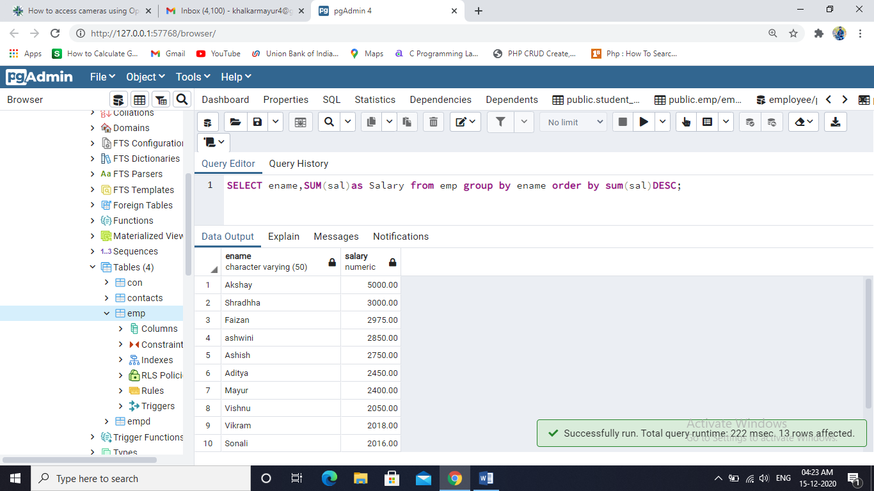

Group By with COUNT SELECT ename,sum(sal) as salary_sum,count(sal)as Salary_count from emp group by ename;

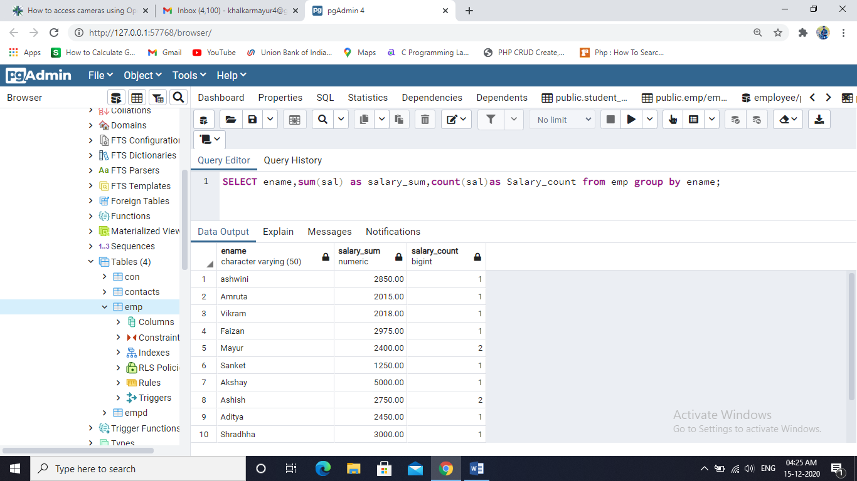

GROUP BY Multiple column

SELECT ename,sum(sal) as salary_sum,count(sal)as Salary_count from emp group by ename,empid order by ename;

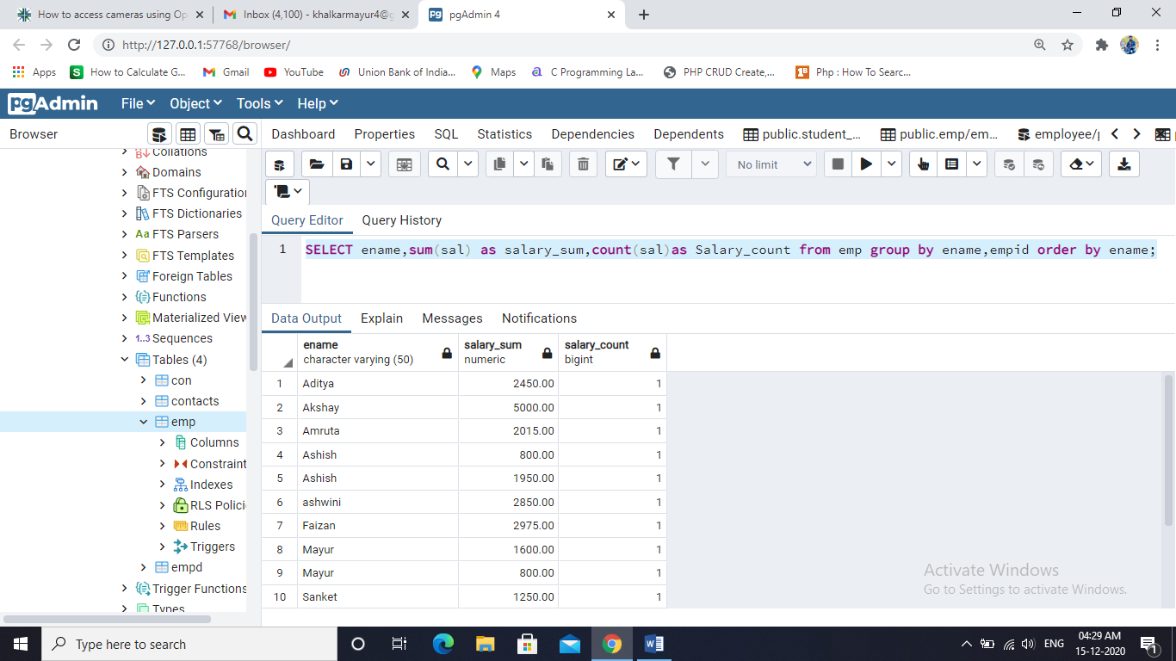

Group By Date

select ename,DATE(hiredate)from emp group by date(hiredate),ename;

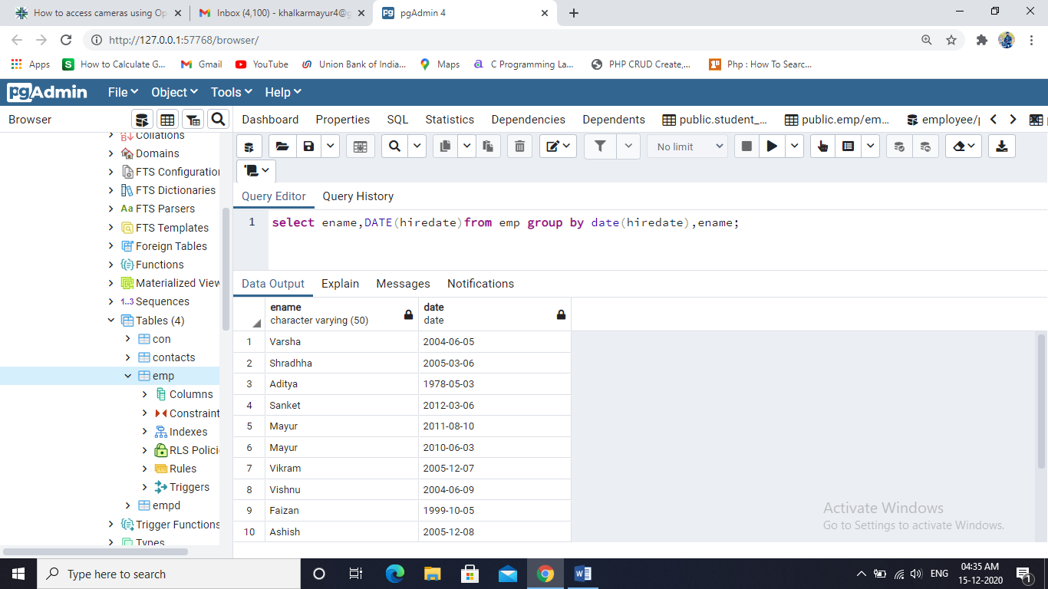

Having Clause With Sum

select ename,sum(sal),count(ename)from emp group by ename having sum(sal)>2500;

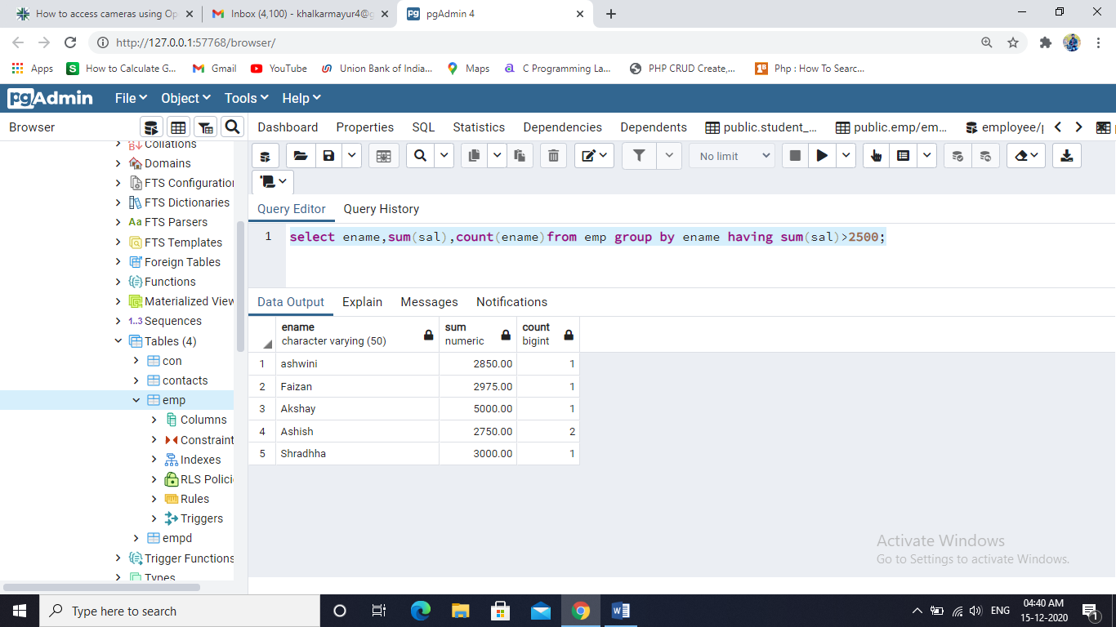

Having Clause With Sum& Count



Use Of SUM() & COUNT()

